Case deliverable A

A) My website will be about my favorite soccer team: AS ROMA. I want to give them information about that team and also a little bit about all the other sport in general. I could also dedicated some additional pages where I could include some activities of that city that any visitors might like.

B) My main target visitors are the AS ROMA fan, but also anyone who wants to be informed about sports. I am expecting visitors from all around the worlds, with any type of social and economic background. My website will be available in the most spoken languages which will make it easier for my visitors. The additional pages could interest any companies that have any activities that want to promote. I will keep the information updated as often as possible so my visitors can be sure that will find mostly all the news related to my soccer team.

C) Website from which I get some inspiration:

<http://www.forzaroma.info/> : The color is mainly red, which is like a symbol of my soccer team. Also there are many pictures which in my opinion give a very nice aspect to the website and makes it looks more attractive to the visitors.

<http://espn.go.com/> : It’s full of articles and also give worldwide information. Even if my website it’s about my soccer team, I think it’s also a good idea including some extra pages where people could also get information about the other international leagues and sport around the world. That makes my website a bit open as well to the whole public in general.

<https://www.amazon.com/gp/gw/ajax/s.html> : I find the searching tools very amazing on that website, I could build a similar one on my website to make it easier for my visitors to find what they are looking for.

<https://www.youtube.com/watch?v=V9n9GU10hVo> : I could create a similar page linked to my website where we could find any video related to my soccer team, including game resume, goals etc.

<http://www.eurosport.com/> : It is a very nice designed webpage and I could try to implement some of those design in my webpage.

Case deliverable B

Social Media

Support

Team Squad

History

Gallery

Video

Serie A

Today

Last Week

Home

News

Competition

Contact

About

Store

Multimedia

More

Champions League

Last Month

European League

Sponsor

Case deliverable C

Welcome to the best AS ROMA fan website

|  |  |  |
| --- | --- | --- |
| Pos | Squad | Pt |
| 1 |  |  |
| 2 |  |  |
| 3 |  |  |
| 4 |  |  |
| 5 |  |  |
| 6 |  |  |
| 7 |  |  |
| 8 |  |  |
| 9 |  |  |
| 10 |  |  |
| 11 |  |  |
| 12 |  |  |
| 13 |  |  |
| 14 |  |  |
| 16 |  |  |
| 17 |  |  |
| 18 |  |  |
| 19 |  |  |
| 20 |  |  |

News | Competition | Multimedia | Store | About | Contact

*Search…*



Most users would like to have a nice picture on the home front page of the team.

Title:

The title will be a hyperlink leading to the actual article. Only the title will be on that page.

Title:

The title will be a hyperlink leading to the actual article. Only the title will be on that page.

*Search…*



News | Competition | Multimedia | Store | About | Contact

**COMPETITION**

**Champions League**

**Serie A**

**Italian Cup**

*Search…*



News | Competition | Multimedia | Store | About | Contact

**MULTIMEDIA**

Video Gallery

1:08 / 4:27

1:08 / 4:27

1:08 / 4:27

1:08 / 4:27

1:08 / 4:27

*Search…*



News | Competition | Multimedia | Store | About | Contact

**STORE**

Description and price

Description and price

*Search…*



News | Competition | Multimedia | Store | About | Contact

**ABOUT**

This website was built by Michel Clerger and Yiliyar Bahetiya. For any question or support please fill the contact form.

*Search…*



News | Competition | Multimedia | Store | About | Contact

**CONTACT**

**Help and support**

To contact us please fill the form below:

Name:

Email:

Message:

Send

**Social media**

Facebook:

Case deliverable D

**Visual design:** For our visual design we built it in accordance to the wireframe of our website. We use a picture of the future stadium of the team as background because for all the AS Roma fan this will be a really meaningful event. We make sure that the titles are bigger than the paragraphs and are readable for the users. We adjust the background image and page color depending on the user’s need. We also mostly use dark colors because based on our research it can be more vision friendly for the navigation during night time as well and also in accordance to the main background image. Below you can find the pictures of the visual aspects of our website, the main pages and some of their subpages.

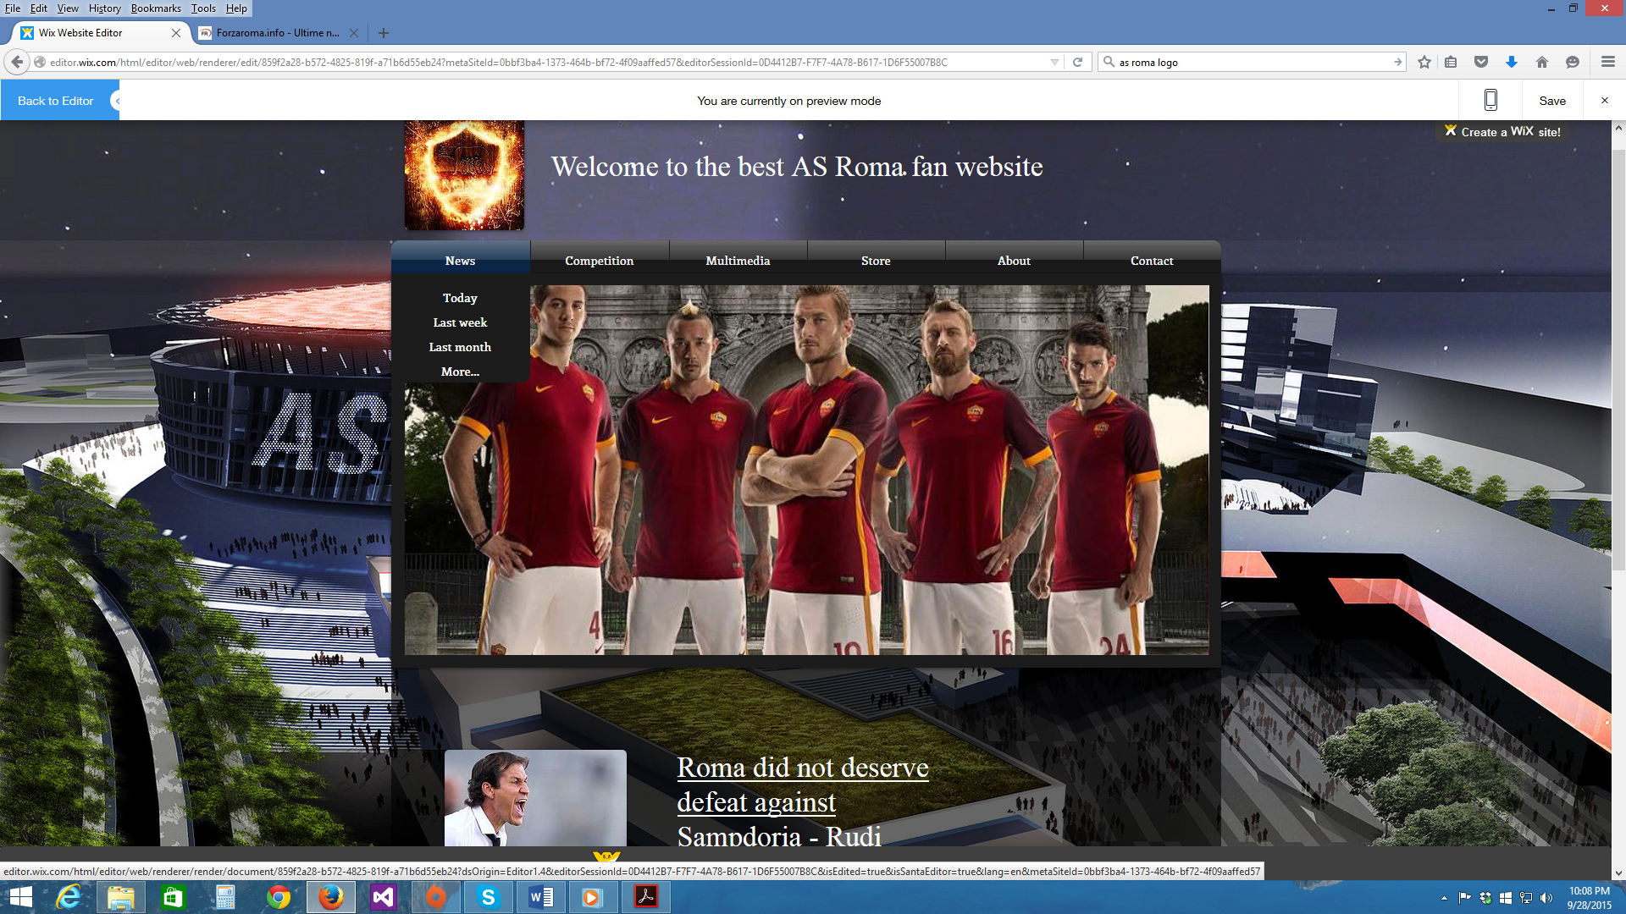

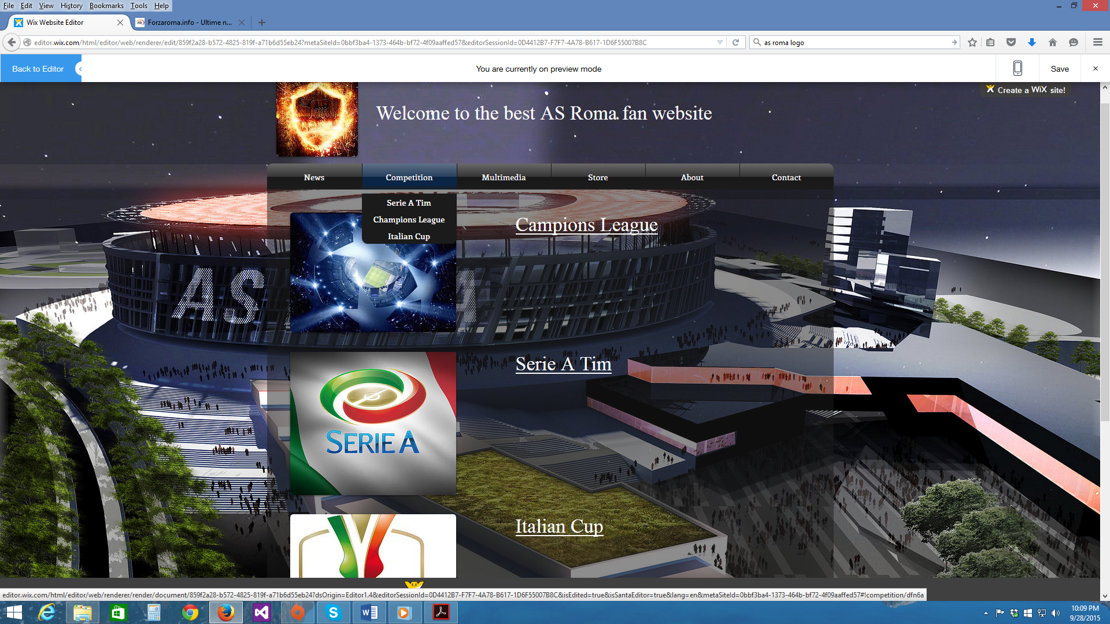

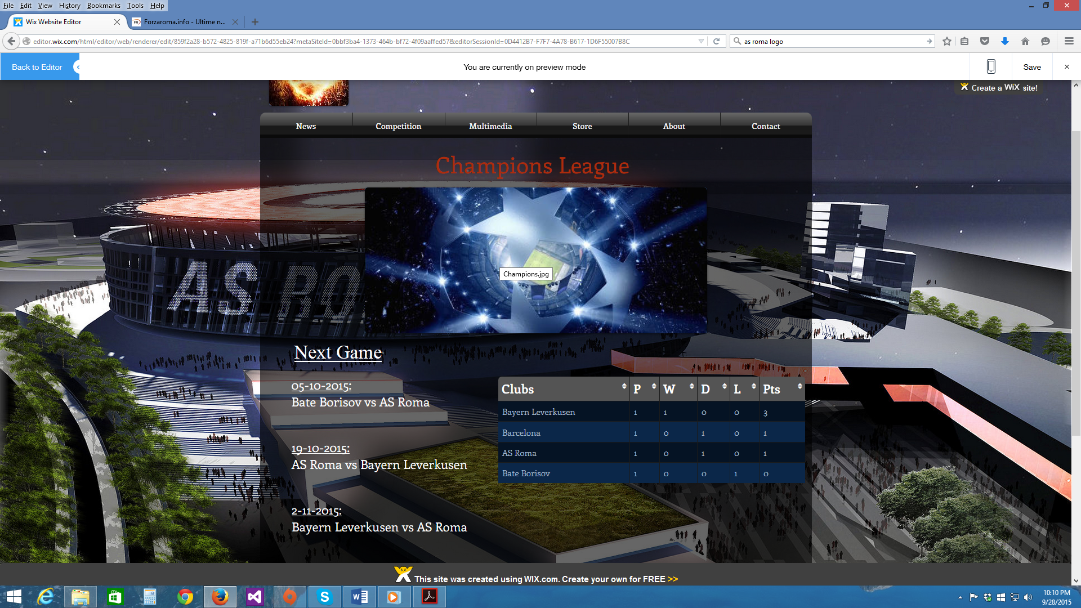

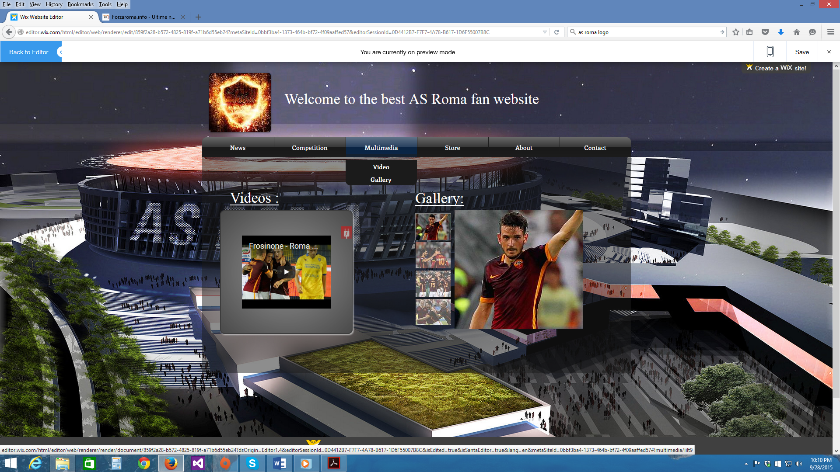

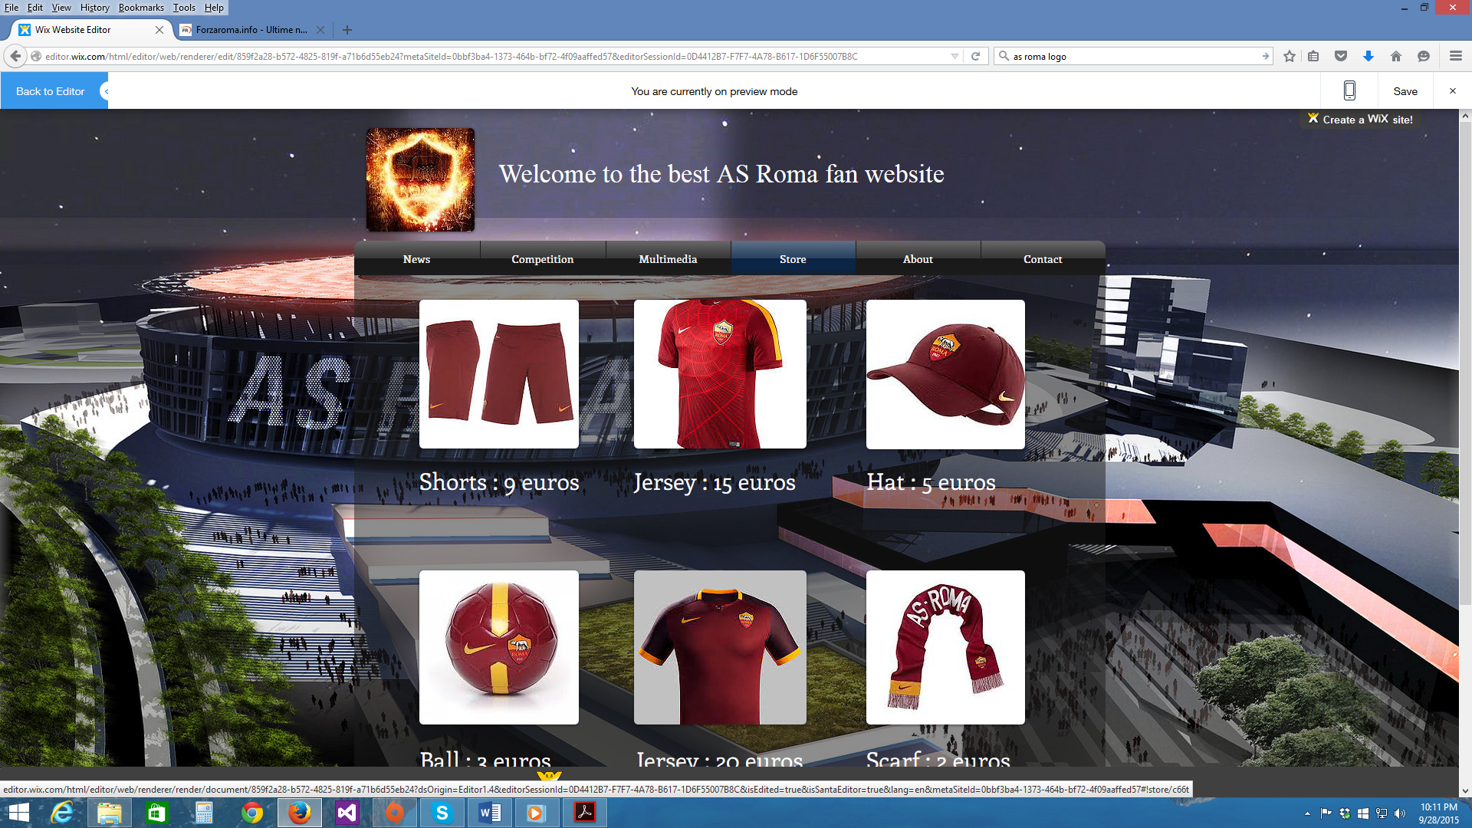

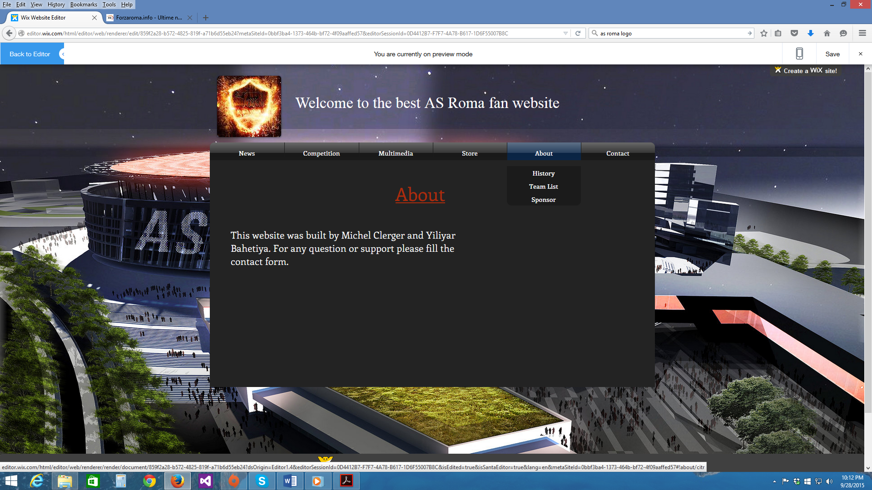

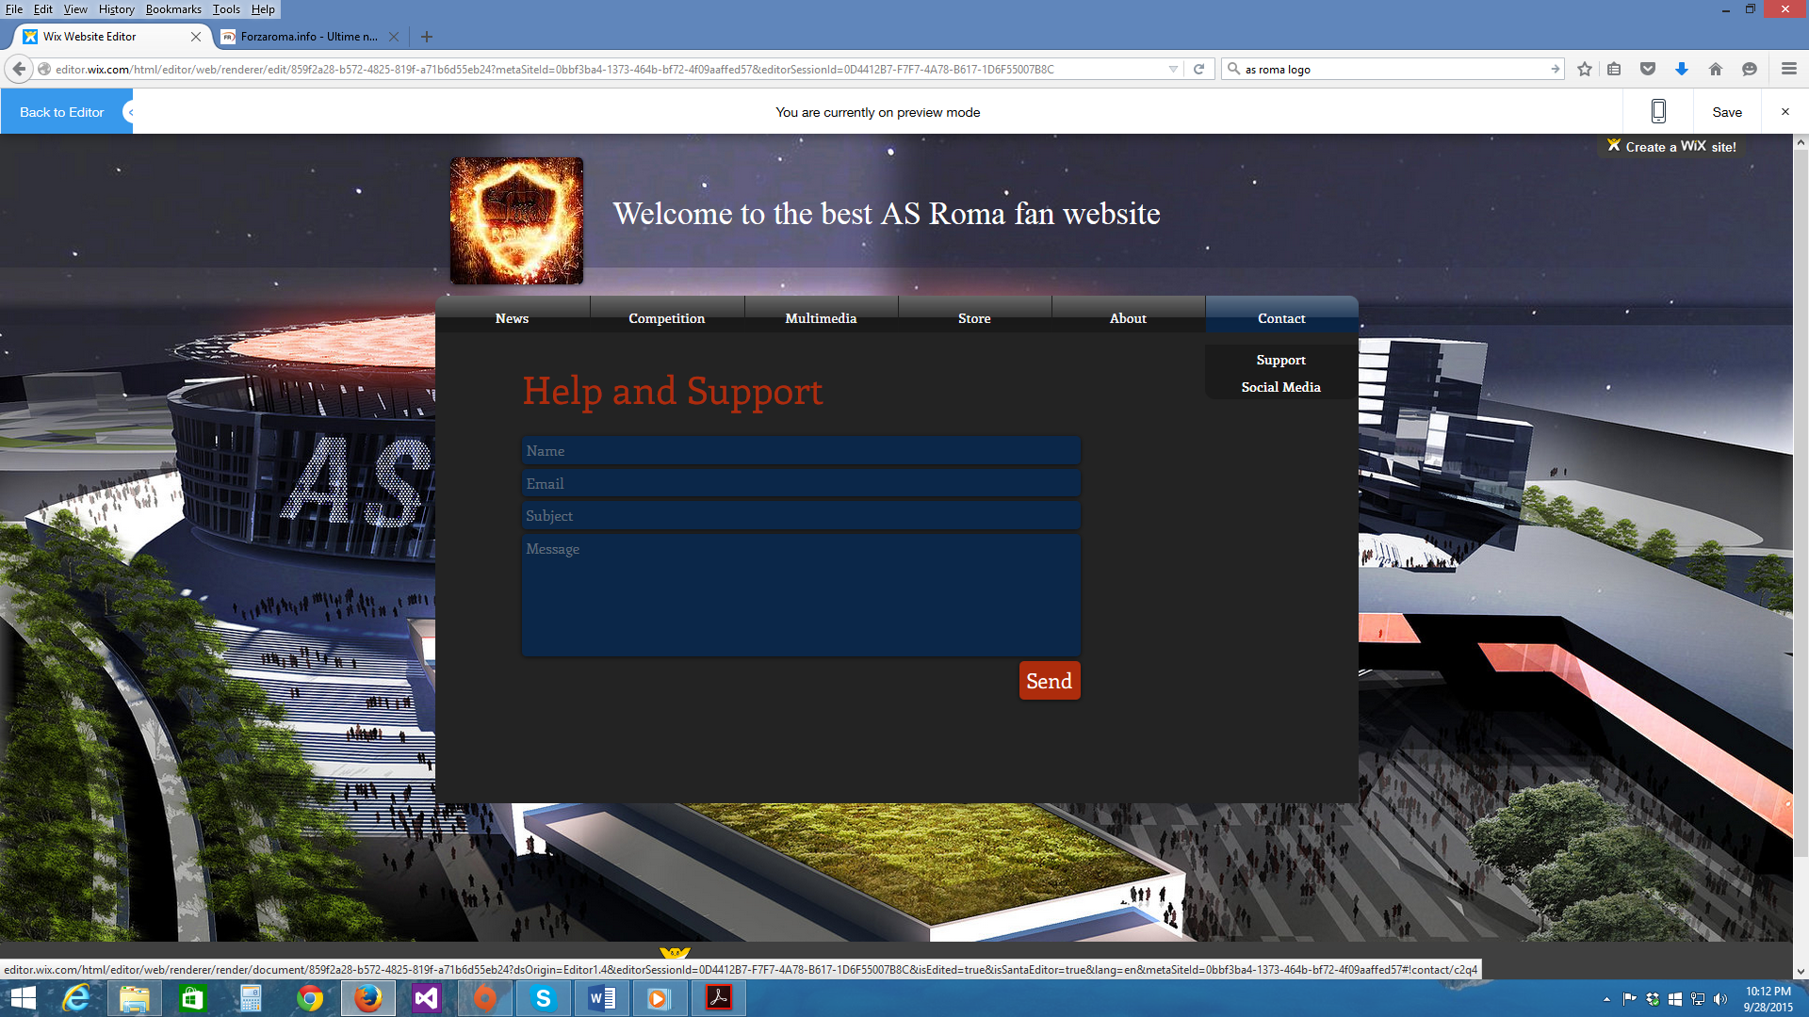

**Layout design:**

Welcome to the best AS ROMA fan website

|  |  |  |
| --- | --- | --- |
| Pos | Squad | Pt |
| 1 |  |  |
| 2 |  |  |
| 3 |  |  |
| 4 |  |  |
| 5 |  |  |
| 6 |  |  |
| 7 |  |  |
| 8 |  |  |
| 9 |  |  |
| 10 |  |  |
| 11 |  |  |
| 12 |  |  |
| 13 |  |  |
| 14 |  |  |
| 16 |  |  |
| 17 |  |  |
| 18 |  |  |
| 19 |  |  |
| 20 |  |  |

Most users would like to have a nice picture on the home front page of the team.

*Search…*



News | Competition | Multimedia | Store | About | Contact

Title:

The title will be a hyperlink leading to the actual article. Only the title will be on that page.

Title:

The title will be a hyperlink leading to the actual article. Only the title will be on that page.

Footer

*Search…*



News | Competition | Multimedia | Store | About | Contact

**COMPETITION**

**Champions League**

**Serie A**

**Italian Cup**

Footer

*Search…*



News | Competition | Multimedia | Store | About | Contact

**MULTIMEDIA**

Video Gallery

1:08 / 4:27

1:08 / 4:27

1:08 / 4:27

1:08 / 4:27

1:08 / 4:27

Footer

News | Competition | Multimedia | Store | About | Contact

*Search…*



**STORE**

Description and price

Description and price

Footer

*Search…*



News | Competition | Multimedia | Store | About | Contact

**ABOUT**

This website was built by Michel Clerger and Yiliyaer Bahetiya. For any question or support please fill the contact form.

Footer

*Search…*



News | Competition | Multimedia | Store | About | Contact

**CONTACT**

**Help and support**

To contact us please fill the form below:

Name:

Email:

Message:

Send

**Social media**

Facebook:

Footer